Bugs in branch: freelancer-230118-redo  
commit id de542ee8217e18bbfe00dd7566debad8c1986512

# The application is not working properly on Mobile browsers: Clicking on any of the markers does not activate the pop-up

FIXED on this branch.

# Each marker should be rounded and have a small triangle pointing to the exact spot

FIXED on this branch.

# When the pop-up is open, clicking on the marker should work the same as clicking on the pop-up:

**Observed behavior:** Clicking outside the pop-up causes the pop-to go away, this is frustrating for the end-user because it is difficult to remember to move the mouse after clicking on the marker.

**Expected behavior:** Clicking in the marker should have same outcome as clicking on the pop-up.

# Excessive refreshing when the map is moved

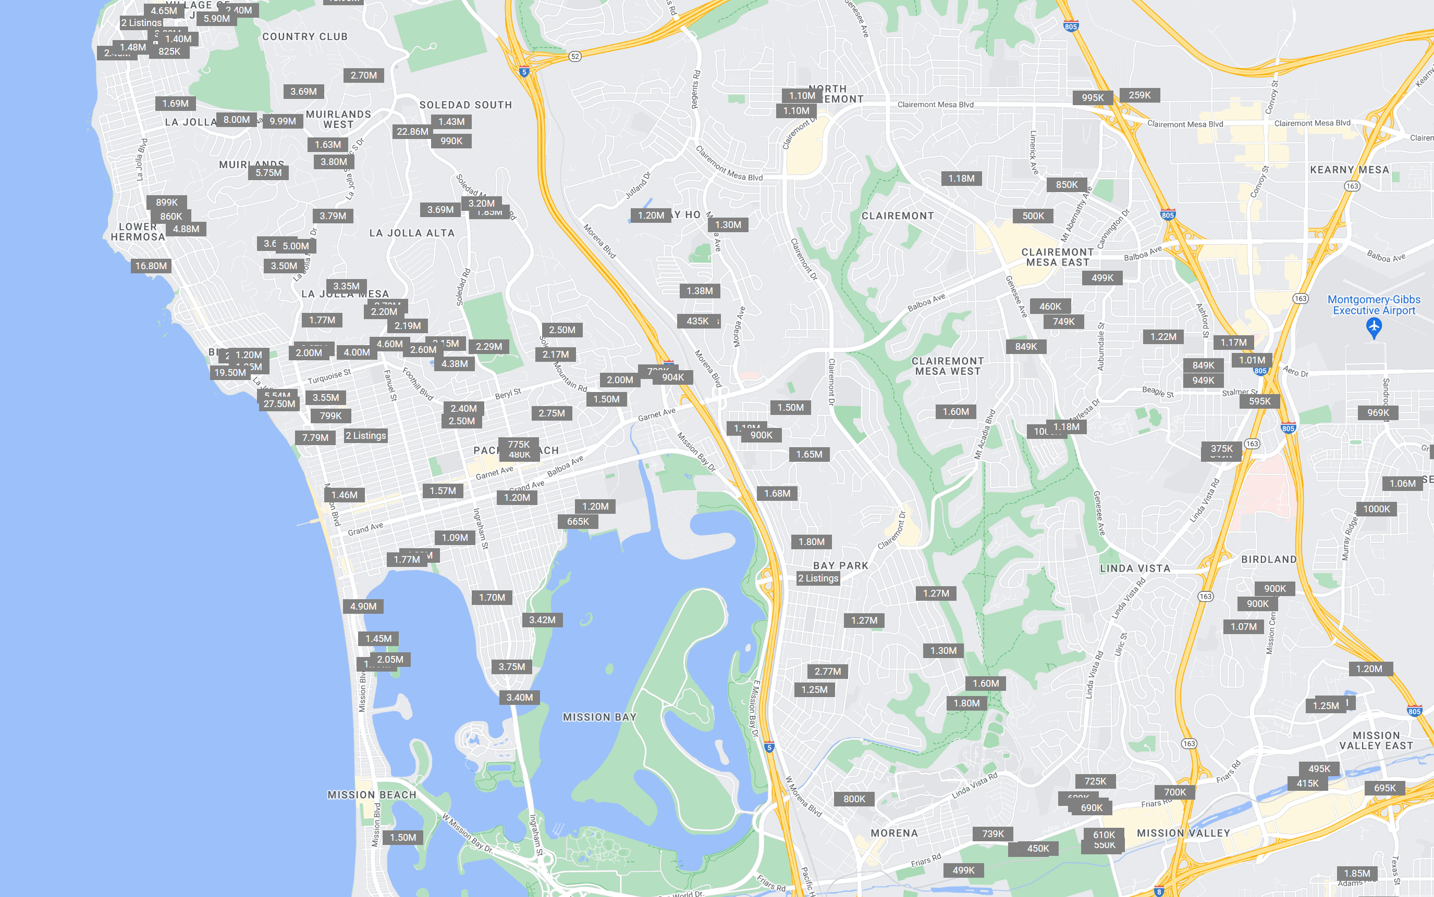

**Actual result:** Currently the entire area is re-queried and redrawn. This is slow and glitchy.

**Expected result:** Moving the map should smoothly request and paint results for the expanded area.

# The calendar under property detail shows “undefined” for the month

FIXED in this branch.

# Refactor: Make configurable display of details

Instead of fixed React Components for each data element, there should be one flexible component e.g. **<DataDrivenDisplay data={data}/>** and it should be driven by a configuration JSON, for example   
[ { section: ”Exterior”, fieldname: ”CmplxUnits”, displayname: ”Units in Complex”, format: “integer” }, { section: “Fact”, … }, … ]

# Use the COMMUNITY names from the ZIPCODES.geojson file and support autocompletion – should also display the zipcode

In this branch we see this:

Desired behavior: 1) It should display the ZIP code next to the name, e.g. “Alpine 91901” instead of just “Alpine”, and 2) The whole list should never shown; only after the user types 1 character the autofiltering should begin.

# The Current Location should be part of the dropdown and should use the browser’s Location API to obtain the user’s current latitude/longitude.

**Observed Behavior:** In the current branch we see this:

**Expected behavior:** the “Current Location” should be a separate thing, it should one of the option that the user sees when they click on the input box, before they start typing (after they type the first character, the autofill should take over instead). When the user does choose Current Location, they should be taken in the map to their real world current location by using Location API e.g. to access mobile phone GPS. You can see something similar to this desired functionality on many well known websites and this SO post: <https://stackoverflow.com/questions/11864174/how-to-get-users-geolocation>

# Usability issues making it difficult for the end-user to click and navigate to the specific item in the pop-up:

**Current behavior:** veryfrustrating for the end-user to get a correct click, because the box disappears when you try to move the cursor, or if you wait it also disappears, and if you click the marker then mothing happens. For example, after mouseover on the “895K” marker, if the cursor touches the street area on the way to clicking the image, the pop-up disappears.

**Expected behavior:** this function should work smoothly and easy for the end-user even if the user cursor movement is not precise. For example, user clicks marker, then goes to click the pop-up, the pop-up should not disappear. If the user clicks the white area or a few pixels above (for example, clicking the area below the marker “895K” and above the white pop-up, should still take the user to the detailed view).

# 10. Fix the alert “An iframe which has both allow-scripts and allow-same-origin for its sandbox attribute can remove its sandboxing.”

Currently this is seen in the browser console:

THIS MAY HAVE ALREADY BEEN FIXED IN THIS BRANCH.

# New bug only in this branch: if you move the mouse quickly, you can see multiple pop-ups:

# When you click the marker, this happens:

(the image is broken)

This bug is only present in the freelancer-230118-redo branch, and not on main.